Country/Region/Global: Djibouti
Initiation Plan

Project Title:Djibouti, inclusive digitalized governance for sustainable development

Expected UNDAF/CP Outcome(s): National and local government institutions and actors ensure the effective, efficient and transparent management of public resources for inclusive and equitable development
Expected CPD Output(s): 3.1 National capacities for inclusive and evidence-based governance and development planning, programming and aid coordination are strengthened for sustainable development

Initiation Plan Start/End Dates:15 June 2019- 31Dec 2019

Implementing Partner: UNDP

Programme Period: 2018 -2020

Atlas Project Number: ______________
Atlas Output ID: ______________

Gender Marker: Gen2

Total resources required US$ 920,000
Total allocated resources: US$ 400,000
- Regular
- Other:
  - Donor UNDP US$, 400,000
  - Donor _________
  - Government _________
Unfunded budget: US$ 520,000
In-kind Contributions _________

Brief Description
Limited functional capacity in public sector institutions and weak governance greatly limit developing countries opportunities in achieving SDGs. Capacity building of institutions is defined as building effective, accountable and responsive institutions to provide public services, address sustainable development issues and build resilience, and reflect on people’s voices in decision-making. UNDP will support national and subnational capacities for inclusive, evidence and digital based governance. Through this project UNDP will work on public institutions capacity development focused on digitalization of governance on a phased approach. The initial phase of this project will respond to the critical demand of a cohort of ministries and specialized agencies that has great potential on impacting Djibouti progress towards achieving the SDGs and gender and inclusion of vulnerable population (women, youth, migrants, refuges and people with disability).

Agreed by UNDP:

Purpose and Expected Output
Situation analysis:
The Republic of Djibouti is a small multi-ethnic nation of 940,000 inhabitants. The country has experienced exceptional economic growth in recent years. The country has experienced exceptional economic growth in recent years by leveraging the country’s strategic location near the world's busiest shipping lanes and close to Arabian oilfields. The member of the League of Arab States (Arab League) and the Common Market for Eastern and Southern Africa (COMESA) is among the top 10 performers in the GDP growth. GDP growth in 2018 is estimated at 7 percent reflecting an acceleration from the estimated 6.5 percent in 2016.
Djibouti has a mixed economic system which includes a variety of private freedom, combined with centralized economic planning and government regulation. The economy has a dual aspect: on the one hand, it has a modern sector based on revenues from ports and military bases leased by foreign countries; on the other hand, it has a large informal sector, of small businesses . Growth is mainly driven by construction and rising transit trade and transhipment for Ethiopia with improved port, transport infrastructure, the China Silk Road and military bases (China, France, Italy, Japan, and the United States).
The Government of Djibouti has engaged into an ambitious reforms program for the public sector to achieved public efficiency and to advance the private sector climate. Djibouti has demonstrated an overall improvement in governance over the last 10 years, and ranks 34th out of 54 on the Ibrahim Index of African Governance (2016). Tthe deployment of e- Government services requires considerable effort in the field of digital administration, and also involves extending the coverage of broadband internet and facilitating internet access. Djibouti has made significant investments to install eight submarine telecommunications cables and has a major advantage in telecommunications. The country plans to take advantage of increased bandwidth to become a hub for ICT development and a platform for digital exchanges. Ssignificant progress has been made in recent years to improve the business climate. Djibouti saw a rise of 55 ranks in the World Bank World Bank’s Ease of Doing Business global rankings for 2019, sitting at 99th globally. Major improvements have been observed in the regulatory framework for credit reporting, minority investor protections, corporate transparency requirements legislation, clarification of corporate governance, ownership and control structures, affordability of starting businesses, increased transparency of information, the creation of a credit information system, among others.
Djibouti faces challenges concerning rights, participation, accountability and public management. While public service delivery and decision power mechanisms remain centralized, the establishment of the Ministry of Decentralization in 2016 and the regional development plans (2017) are good opportunities to improve coordination and delivery of basic services and sustainable development goals at local level. The public policy monitoring and evaluation system is nascent, and, with support from UNDP, the Government recently launched a framework of dialogue for aid coordination aligned with the four axes of its accelerated growth strategy to facilitate cross-sectoral coordination within the Government and with development partners. Civil society, the private sector and academia will gradually be integrated into the framework.
Public administration:
The Djiboutian public administration struggled to recover from the internal crisis of the 1990s and the structural adjustment program that followed. Since then, the dysfunction of the State services is a major concern of the public authorities and development partners. As such, in 1997 a public administration reform was launched as part of a partnership agreement with the IMF and the World Bank to reform public enterprises and provide technical assistance for economic reform. However, the recommendations and action plans based on the diagnosis prepared by the National Commission for Institutional Reform created to accompany the process, remained a dead letter. The 2009 assessment of the public sector revealed that things have deteriorated: the administration is characterized by anachronism, heavy bureaucracy and considerable shortcomings that constitute a real obstacle to the new economic demands. The President of the Republic pointed the issue of administrative reform as one of the priorities for the government. The objective is to improve the performance and efficiency of the public administration so that it is able to support the economic and social development of the country. The European Union recently commissioned an assessment of the public sector reform that revealed the need for developing frameworks ensuring efficient management of its human resources, and the need for the establishment of a genuine reform driving capacity. Government recently set up an anticorruption commission to revise the legislation framework on corruption and enforcement of the government preventive measures. The newly established commission requires capacity enhancement.
Project strategy:

Limited functional capacity in public sector institutions and weak governance greatly limit developing countries opportunities in achieving SDGs. Capacity building of institutions is defined as building effective, accountable and responsive institutions to provide public services, address sustainable development issues and build resilience, and reflect on people’s voices in decision-making. UNDP will support national and subnational capacities for inclusive, evidence and digital based governance. Through this project UNDP will work on public institutions capacity development focused on digitalization of governance on a phased approach. The iInitial phase of this project will respond to the critical demand of a cohort of ministries and specialized agencies that has great potential on impacting Djibouti progress towards achieving the SDGs and gender and inclusion of vulnerable population (women, youth, migrants, refuges and people with disability). These includes Ministries and institutes that influence development planning, national budget allocation, development finance, public institutions reform, monitoring and evaluation of public performance. UNDP interventions will provide technical assistance for:
➢ Public institution capacity assessment, identification critical gaps, technical assistance requirement and Business process analysis and reengineering;
➢ Addresses Priorities of departments, ministries and states in implementing flagship SDGs localization schemes and programmes
➢ Support to Civil Service Management, strengthening national and local public administration systems for human resource and performance management through digitalization of the operation systems;
➢ Technical assistance for strategic advisory and policy support to the centre of government on targeted high-level policy dialogues, workshops and public lectures .
➢ Public Financial Management supporting fiscal discipline at all levels, with appropriate strategic resource allocation and budgetary/expenditure efficiency by digitalization of systems to execute and achieve national development goals and SDGs.
➢ Transparency and accountability enhancement to advance open government practices, social accountability and public integrity
➢ ICT-enabled public institutions and E-government for leaving no one behind. The increasing use of ICTs by institutions will provide an opportunity to dramatically impact public services and their delivery , both via Internet websites and portals, mobile and especially smart phones, social media, and kiosks situated in places accessible to the public. ICT-enabled public service delivery is having a signiﬁcant impact, as it is much more affordable for an increasing number of users and more cost effective for governments than traditional supply channels. ICT use also enables more targeted, personalized and up-to-date service design and delivery. That gives the service user greater beneﬁts than the sole reliance on traditional service channels, in terms of access, convenience through 24/7 availability, savings in time, and the cost of travel to physical premises such as ofﬁces. It also opens the possibility of new types of public services for achieving the SDGs by 2030.
➢ Facilitate a regional workshop, planned to be held in September 2019 , on e-Governance by bring together cases from other countries in the Arab States, with the aim to discuss challenges and good practices on digitalization of public administration, inclusive participation for decision-making through online platforms, and improved data collection via innovative methods. The key recommendations that will emerge from the workshop will provide guidance in the overall implementation of this project.

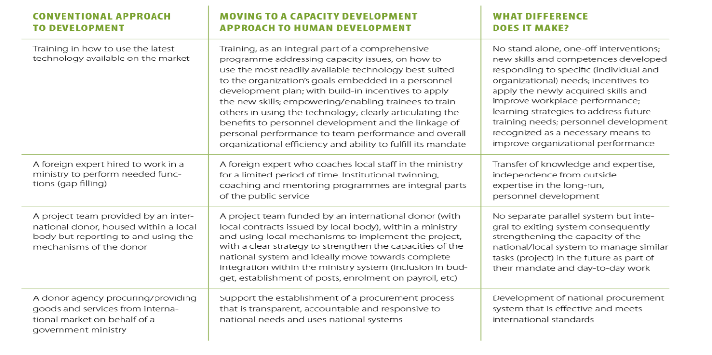
Figure 1: UNDP Capacity Development approach V/S conventional approach

Management Arrangements
UNDP will partner with the Prime Minister Office, Ministry of Foreign Affairs and International Cooperation, the Ministry of Economy and Finance, the Ministry of budget, the Ministry of labour, Ministry of Interior, Ministry of Decentralization, United Nations organizations, OECD and the World Bank to facilitate synergize, harmonization and acceleration of governance capacity enhancement to accelerate the sustainable development goals.
The country office will appoint a dedicated project manager to manage the project initiation plan outputs and deliverable

Project Manager

Project Board
Senior Beneficiary
Ministry of Finance and Economy
Executive
UNDP
Senior Supplier
UNDP

Project Assurance
(by Board members or delegated to other individuals)

Project Support

Project Organisation Structure
TEAM A
Public capacity Development

TEAM C
Government M&E system
TEAM B
Digital governance

Monitoring
UNDP programme officer will provide quality assurance to the PIP implementation. End of year report will be submitted to the regional bureau.

WORK PLAN Period:Year: 2019
EXPECTED OUTPUTS  And baseline, associated indicators and annual targets | PLANNED ACTIVITIES  List activity results and associated actions | TIMEFRAME |  |  |  | RESPONSIBLE PARTY |  | PLANNED BUDGET
 |  | Q1 | Q2 | Q3 | Q4 |  |  | Funding Source | Budget Description | Amount
Output 1  Institutionalcapacity development plan is formulated, and critical gaps are addressed  Baseline:  EU assessment of public sector revealed multiple gaps in governance capacity and business processes  Indicators:  Targets:  Related CP outcome:  National capacities for inclusive and evidence-based governance and development planning, programming and aid coordination are strengthened for sustainable development | 1. Activity Result: Public Institutions capacity assessment and development plan  - Action: deploy technical expertise  - Action: conduct capacity assessment |  |  |  |  |  | UNDP | UNDP | Technical & Advisory Services  (LTA) | 300,000
 | 2. Activity Result: Public business process reengineering  - Action: recruit a technical assistance firm to conduct consultation and designing of public business process and training on the new business process |  |  |  |  |  | UNDP | UNDP | Technical & Advisory Services (LTA) | 200,000
 | 3. Activity Result: support to legalization of the public reform  - Action: hire international experts to design the legal frame for public reform |  |  |  |  |  | UNDP | UNDP | Legal experts | 70,000
 | 4. Activity Result: Public transparency, monitoring and evaluation platform  - Action: hire technical experts to support design government performance M&E system.  - Action: create digital portal for public opinion and enhance transparency |  |  |  |  |  | UNDP | UNDP | M&E experts | 50,000
 |  |  |  |  |  |  | UNDP | UNDP | Digital platform design | 70,000
Output 2:  ICT-enabled public institutions and E-government supported  Baseline:  The government established specialized agency for digital governance but there is no roadmap and milestones for the e-governance  Indicators:  Targets:  Related CP outcome:  National capacities for inclusive and evidence-based governance and development planning, programming and aid coordination are strengthened for sustainable development | 1. Activity Result: Government cloud and services are established  - Action: conduct needs assessment for digital government  - Action facilitate and promote digital government services plat form |  |  |  |  |  | UNDP | UNDP | Technical & Advisory Services (leveraging Djibouti and Estonia MOU) | 200,000
2. Activity Result

- Action
TOTAL

Maximum 18 months

